Tutorial 1 - SPM (wk4 done)
Note: For calculation/practical questions, EACH assignment team shares ONE set of answer, i.e. if 4 assignment teams then only 4 sets of answers will be shared in the answer file. [Show all the workings clearly].

Q1 (prepared by Team 2)
Question
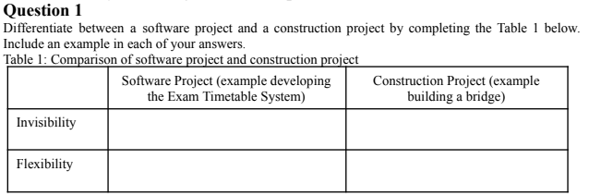

Answer

 | Software Project (example developing the Exam Timetable System) | Construction Project (example building a bridge)
Invisibility | Progress is not immediately visible  E.g. Writing backend code for generating optimal exam schedules - no visual change yet | Progress is immediately visible  E.g. Bridge foundation laid or pillars constructed can be clearly seen
Flexibility | Easier to change  E.g. Updating the scheduling algorithm or changing user interface layout after testing | Difficult to change once it is completed  E.g. Changing the bridge span or adding extra lanes after construction is costly and complex

Q2 (prepared by Team 1)

T-Shirts2U is a small company which supplies and manufactures customized t-shirts. However, its current system which is partially automated is unable to keep track of the orders and stocks efficiently. Besides that, it is unable to provide accurate information to the management on which items are more profitable and there have been mistakes in some of the order fulfillments. In order to solve these problems, the senior management of T-Shirts2U has requested you to develop a new online ordering system to increase the company annual sales by RM50,000. The new system to be developed has the following modules: Customer, Order carts, Online payment and Order fulfillment. This project must be completed within 3 months with an allocated budget of RM180,000. The project team consists of six software developers.

a.Identify and explain TWO (2) constraints of T-shirt2U project implementation. Explain your answer.

1.Time Constraint
- The project must be completed within 3 months. This is a strict time frame that limits how much work can be done and how detailed or advanced the system can be. Any delay in development, testing, or deployment could result in project failure or missing business objectives.

2.Budget Constraint
- The allocated budget is RM180,000. This. Budget restricts how many resources can be used (e.g., hiring more developers, purchasing software/tools, or conducting extensive testing). The team must manage cost carefully to avoid overspending while still delivering all required modules.

b. The outcome of a project can be classified as truly successful, partially successful or a total failure.
Identify and explain TWO (2) criteria that can be used to judge the above project whether it is a total failure.

1.Failure to Meet Business Objectives
- If the system fails to increase annual sales by RM50,000, it means the core business goal is not achieved. Despite technical completion, not achieving this target would classify the project as a failure in terms of return on investment.

2.Non-Completion Within Constraints
- If the project exceeds the 3-month timeline or goes over the RM180,000 budget, it fails to meet its key constraints. This could result in financial loss, stakeholder dissatisfaction, and the system potentially being or not deployed on time.

Q3 (prepared by Team 3)
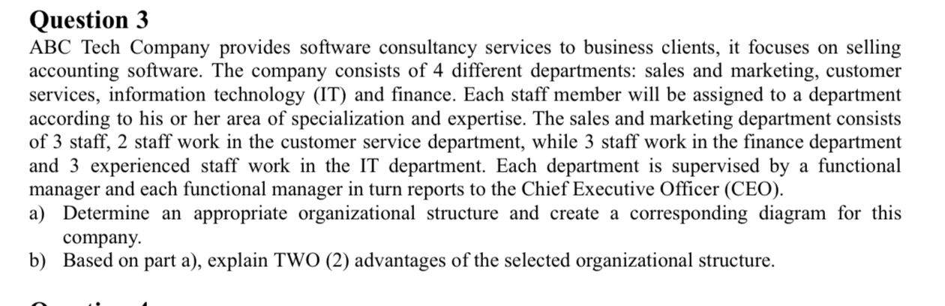
a.
Functional Organizational Structure
- Each department is independent and has a clear functional focus.
- It supports specialization and technical excellence.
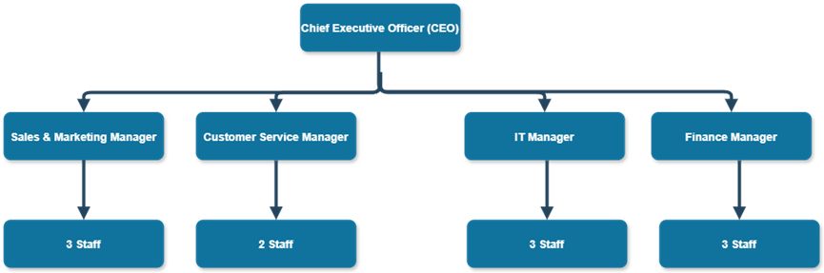

b.Based on part a), explain TWO (2) advantages of the selected organizational structure.
1. Specialization and Expertise Development
- Employees are grouped by similar skills and tasks (e.g., IT staff under the IT department), which fosters expertise in specific domains. This leads to higher efficiency and quality output.

2. Clear Reporting and Supervision
- Each employee reports to a functional manager, ensuring well-defined roles and streamlined decision-making within each department.

Q4 (prepared by Team 2)

Question
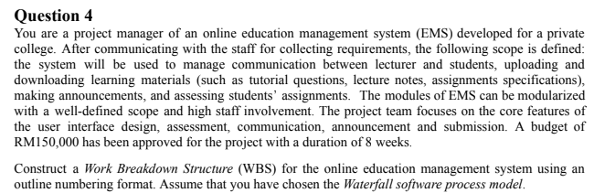

Answer
1.0 Requirement analysis phase
1.1 Requirements gathering
1.1.1 Stakeholder meeting with college staff
1.2 Requirements analysis
1.3 Requirements documenting
1.4 Requirements reviewing
2.0 System design phase
2.1 Design system architecture
2.2 Design system ui
2.3 Design system database
2.4 Define system modules
2.4.1 Communication module
2.4.2 Learning Materials module
2.4.3 Announcements module
2.4.4 Assessment module
2.5 Prepare design documentation
3.0 System development phase
3.1 Develop system modules
3.1.1 Develop communication module
3.1.2 Develop learning materials module
3.1.3 Develop announcements module
3.1.4 Develop assessment module
3.2 Develop system ui
3.3 Develop system database
3.4 Integrate all system modules
4.0 Testing phase
4.1 Unit testing
4.2 Integration testing
4.3 System testing
4.4 User Acceptance Testing
5.0 Deployment phase
5.1 Setting up hardware environment
5.2 Software installation
5.3 Database migration
5.4 Deploy system on live server
5.5 User training
6.0 Maintenance phase
6.1 Monitor system performance
6.2 Develop and deploy bug fixes
6.3 Collect user feedback for improvements

Q5 (prepared by Team ?)

Team 1
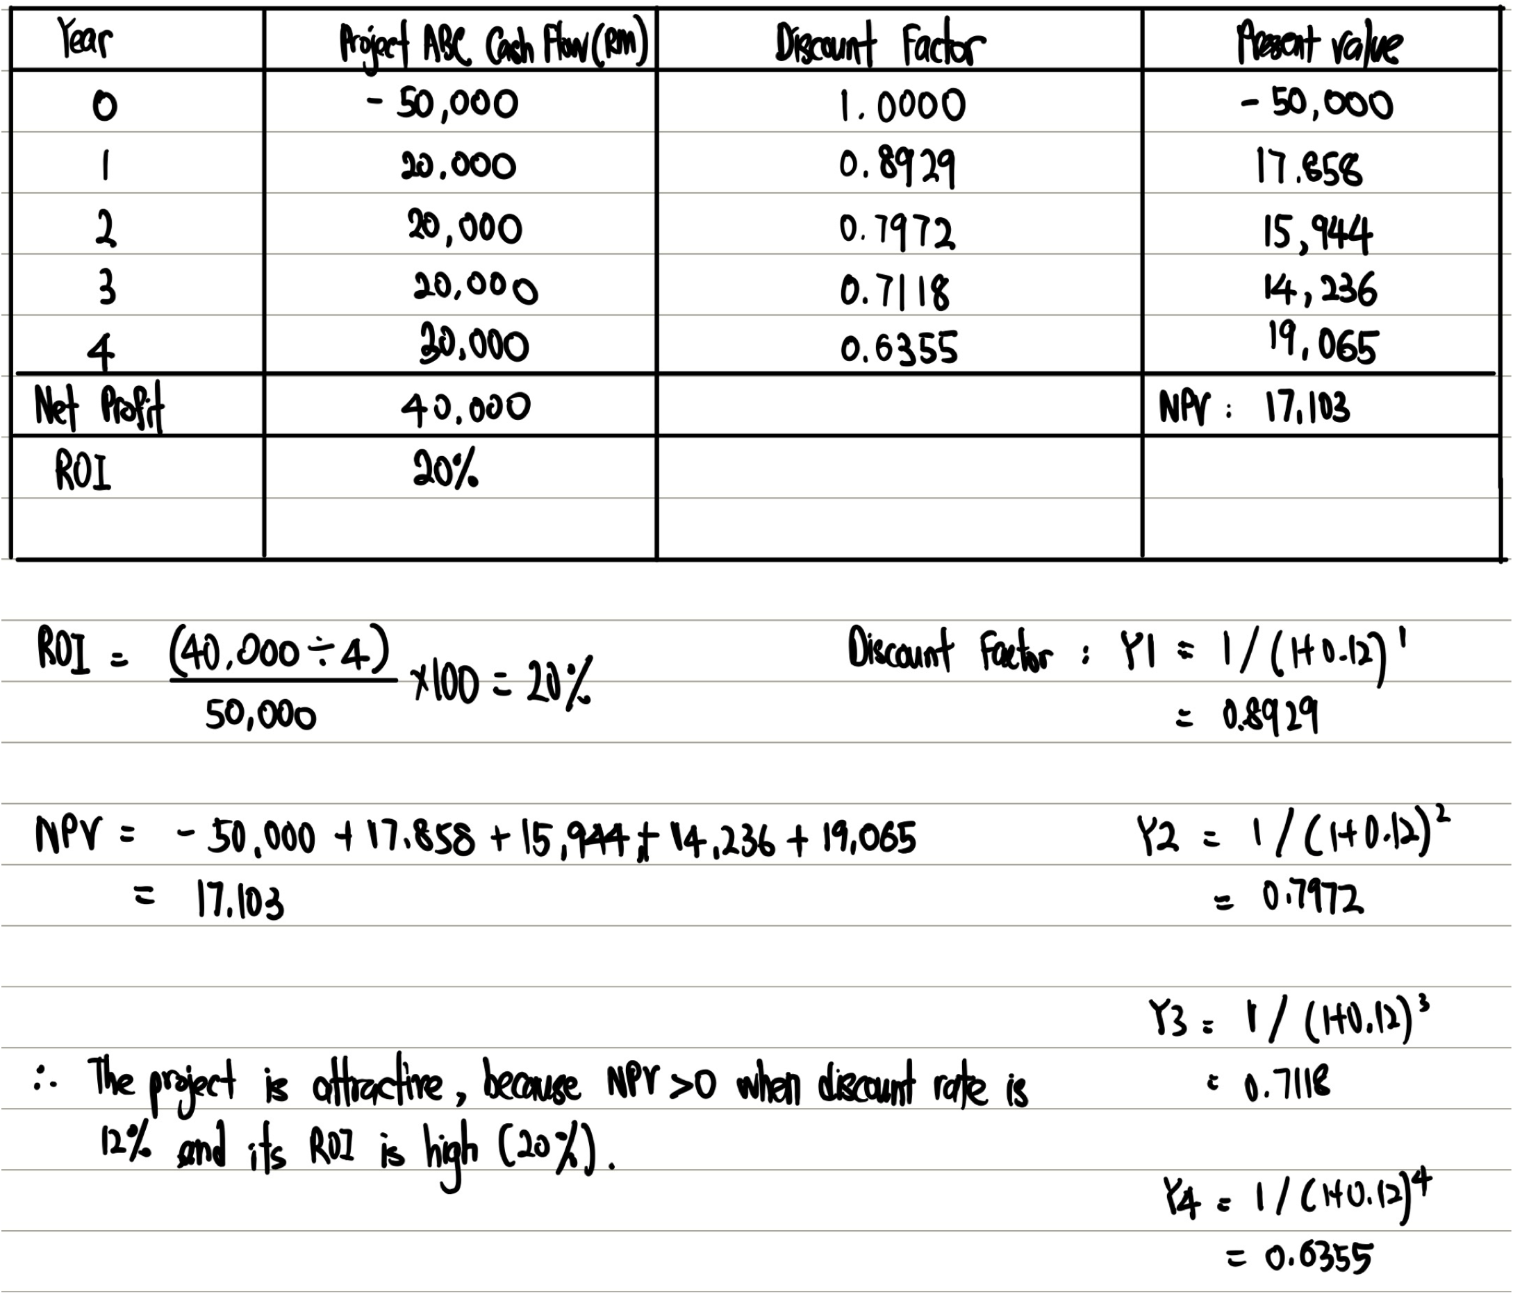

Team 2
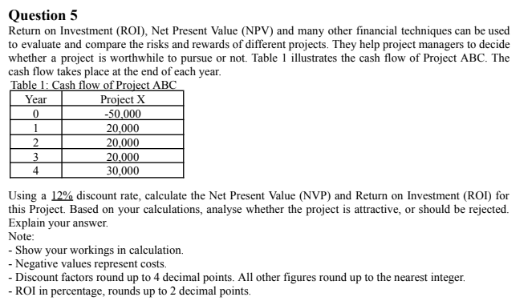
NPV = Present Value of Cash Inflows - Initial Investment

Year | Cash Flow (RM) | Discount Factor | PV (RM)
0 | -50,000 | 1 / (1 + 0.12) ^ 0 = 1.0000 | -50,000 * 1.0000 = -50,000
1 | 20,000 | 1 / (1 + 0.12) ^ 1 = 0.8929 | 20,000 * 0.8929 = 17,858
2 | 20,000 | 1 / (1 + 0.12) ^ 2 = 0.7972 | 20,000 * 0.7972 = 15,944
3 | 20,000 | 1 / (1 + 0.12) ^ 3 = 0.7118 | 20,000 * 0.7118 = 14,236
4 | 30,000 | 1 / (1 + 0.12) ^ 4 = 0.6355 | 30,000 * 0.6355 = 19,065

NPV = -50,000 + 17,858 + 15,944 + 14,236 + 19,065
= RM 17,103

Return on Investment (ROI)

Net Profit = Total Inflows - Initial Investment
= (20,000 + 20,000 + 20,000 + 30,000) - 50,000
= 90,000 - 50,000
= RM 40,000

Method 1
ROI = (NPV/ Discount Cost) * 100%
= 17103/50000 100%
= 34.21%

Method 2
ROI = (Average Annual Profit / Total Investment) *100%
= ((40,000 / 4) / 50,000) * 100%
= 20.00%

Based on the calculation of ROI and NPV, Project X is attractive. This is because the ROI is 20%, which means the company gets to earn 20% from their investment within 4 years. Besides, Project X NPV is positive.A positive NPV indicates the project is profitable [PV of cash inflows (benefits) > PV of cash outflows (costs) over the 4-year period]. Project X has achieved the 12% target rate of return. This result shows that the project is expected to be profitable and financially worthwhile.

Team 3
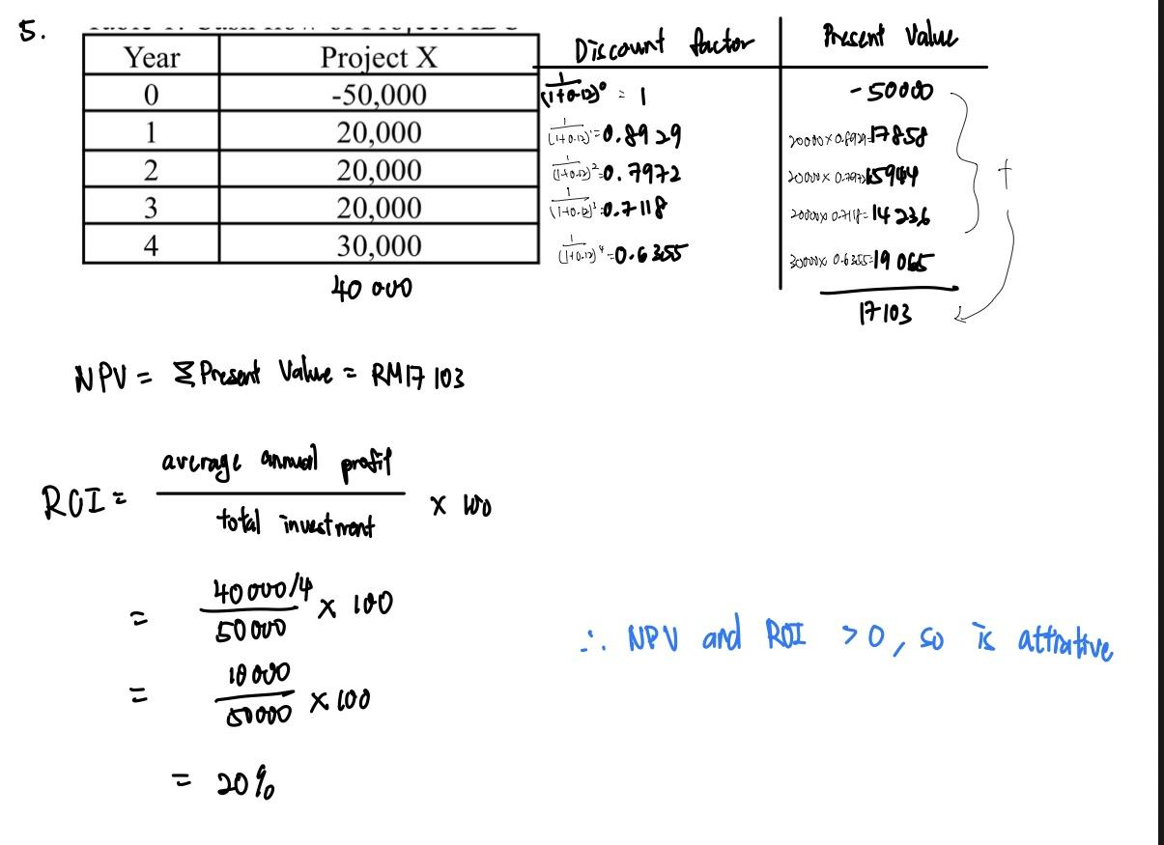

Team 4
Question 5
Year | Project X | Discount Factor | Present Value
0 | -50,000 | 1/(1+0.12)^0 = 1.0000 | -50,000 * 1.0000 = -50,000
1 | 20,000 | 1/(1+0.12)^1 = 0.8929 | 20,000 * 0.8929 = 17,858
2 | 20,000 | 1/(1+0.12)^2 = 0.7972 | 20,000 * 0.7972 = 15,944
3 | 20,000 | 1/(1+0.12)^3 = 0.7118 | 20,000 * 0.7118 = 14,236
4 | 30,000 | 1/(1+0.12)^4 = 0.6355 | 30,000 * 0.6355 = 19,065
Net Profit | -50,000 + 20,000 + 20,000 + 20,000 + 30,000 = 40,000
NPV | -50,000 + 17,858 + 15,944 + 14,236 + 19,065 = 17,103
ROI(Method 1) | (40,000/4)/50,000*100 = 20%
ROI(Method 2) | NPV/Discounted Cost * 100% = (17,103/50,000)*100% = 34.21%

Based on the calculation of ROI and NPV, Project X is attractive. This is because the ROI is 20%, which means the company gets to earn 20% from their investment within 4 years. Besides, Project X has reflected positive NPV which indicates the project is profitable as the present value of inflows (benefits) is larger than the present value of outflows (cost) over the 4-year period. Project X has achieved the 12% target rate of return. This result shows that the project is expected to be profitable and financially worthwhile.

Q6 (prepared by Team ?)

Team 1
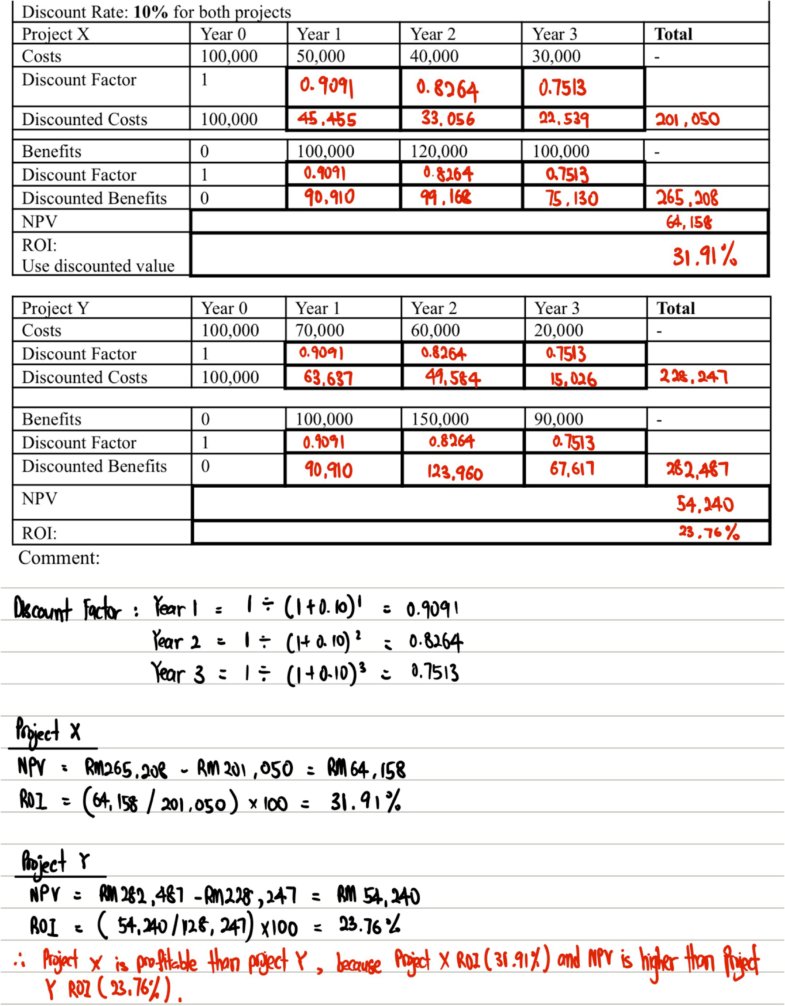

Team 2
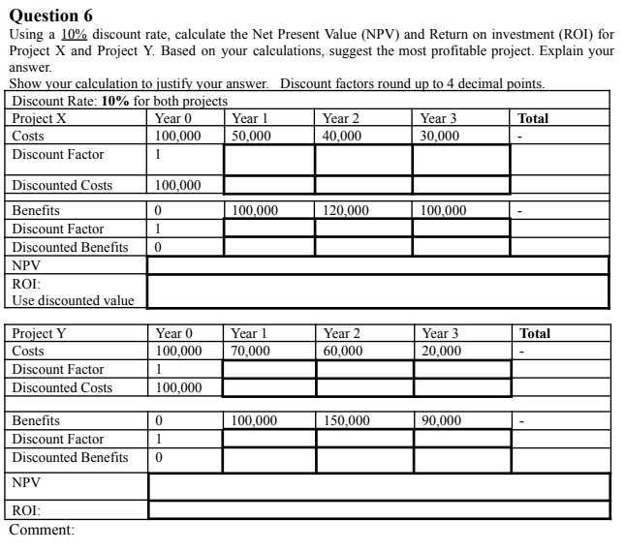

Discount Rate: 10% for both projects
Project X | Year 0 | Year 1 | Year 2 | Year 3 | Total
Costs | 100,000 | 50,000 | 40,000 | 30,000 | -
Discount Factor | 1 / (1 + 0.10) ^ 0 = 1.0000 | 1 / (1 + 0.10) ^ 1 = 0.9091 | 1 / (1 + 0.10) ^ 2 = 0.8264 | 1 / (1 + 0.10) ^ 3 = 0.7513
Discounted Costs | 100,000 * 1.000 = 100,000 | 50,000 * 0.9091 = 45,455 | 40,000 * 0.8264 = 33,056 | 30,000 * 0.7513 = 22,539 | 100,000 + 45,455 + 33,056 + 22,539 = 201,050
Benefits | 0 | 100,000 | 120,000 | 100,000 | -
Discount Factor | 1 / (1 + 0.10) ^ 0 = 1.0000 | 1 / (1 + 0.10) ^ 1 = 0.9091 | 1 / (1 + 0.10) ^ 2 = 0.8264 | 1 / (1 + 0.10) ^ 3 = 0.7513
Discounted Benefits | 0 * 1.000 = 0 | 100,000 * 0.9091 = 90,910 | 120,000 * 0.8264 = 99,168 | 100,000 * 0.7513 = 75,130 | 0 + 90,910 + 99,168 + 75,130 = 265,208
NPV | Total Discount Benefit - Total Discount Cost  265,208 - 201,050 = 64,158
ROI | (NPV/ Discount Cost) * 100%  (64,158 / 201,050) * 100 = 31.91%

Use discounted value
Project Y | Year 0 | Year 1 | Year 2 | Year 3 | Total
Costs | 100,000 | 70,000 | 60,000 | 20,000 | -
Discount Factor | 1 / (1 + 0.10) ^ 0 = 1.0000 | 1 / (1 + 0.10) ^ 1 = 0.9091 | 1 / (1 + 0.10) ^ 2 = 0.8264 | 1 / (1 + 0.10) ^ 3 = 0.7513
Discounted Costs | 100,000 * 1.000 = 100,000 | 70,000 * 0.9091 = 63,637 | 60,000 * 0.8264 = 49,584 | 20,000 * 0.7513 = 15,026 | 100,000 + 63,637 + 49,584 + 15,026 = 228,247
Benefits | 0 | 100,000 | 150,000 | 90,000 | -
Discount Factor | 1 / (1 + 0.10) ^ 0 = 1.0000 | 1 / (1 + 0.10) ^ 1 = 0.9091 | 1 / (1 + 0.10) ^ 2 = 0.8264 | 1 / (1 + 0.10) ^ 3 = 0.7513
Discounted Benefits | 0 * 1.000 = 0 | 100,000 * 0.9091 = 90,910 | 150,000 * 0.8264 = 123,960 | 90,000 * 0.7513 = 67,617 | 0 + 90910 + 123,960 + 67,617 = 282,487
NPV | Total Discount Benefit - Total Discount Cost  282,487 - 228,247 = 54,240
ROI (Use discounted value) | (NPV/ Discount Cost) * 100%  (54240 / 228,247) * 100 = 23.76%

Project X NPV is positive. A positive NPV indicates the project is profitable [PV of cash inflows (benefits) > PV of cash outflows (costs) over the 4-year period]. Project X NPV is > Project Y (PX is profitable than PY)

Team 3
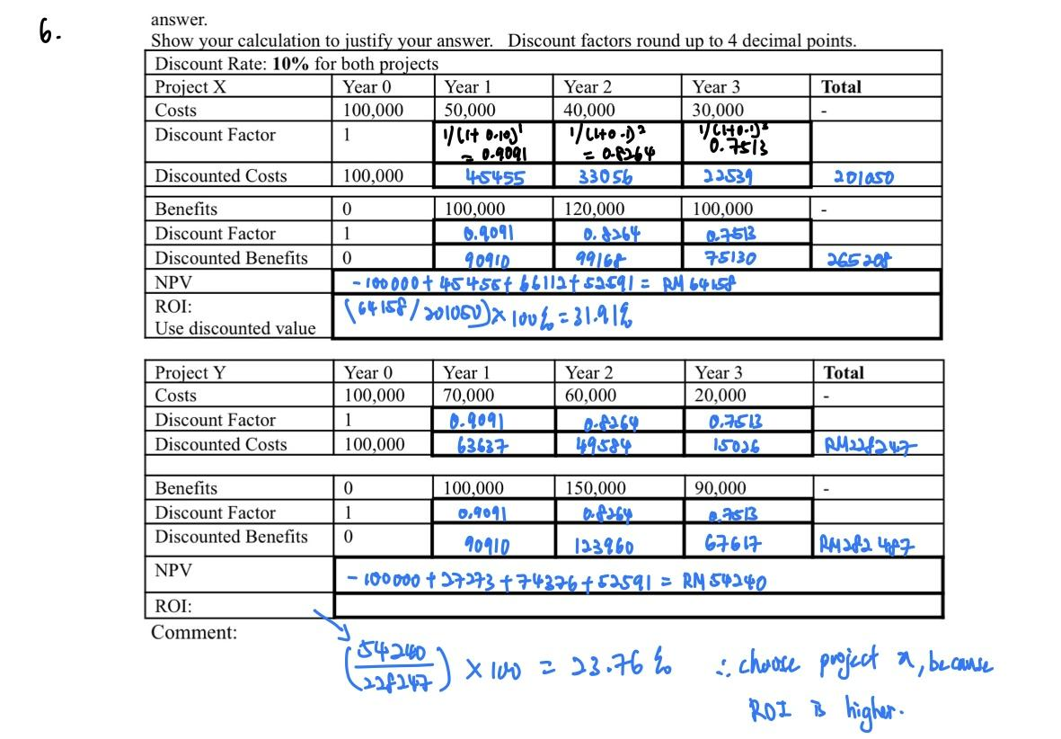

Team 4
Question 6
Discount Rate : 10% for both project
Project X | Y0 | Y1 | Y2 | Y3 | Total
Costs | 100,000 | 50,000 | 40,000 | 30,000 | -
Discount Factor | 1/(1+0.1)^0 = 1.0000 | 1/(1+0.1)^1 = 0.9091 | 1/(1+0.1)^2 = 0.8264 | 1/(1+0.1)^3 = 0.7513 | -
Discounted Costs | 100,000 * 1.0000 = 100,000 | 50,000 * 0.9091 = 45,455 | 40,000 * 0.8264 = 33,056 | 30,000 * 0.7513 = 22,539 | 100,000 + 45,455 + 33,056 + 22,539 =201,050
Benefits | 0 | 100,000 | 120,000 | 100,000 | -
Discount Factor | 1 | 0.9091 | 0.8264 | 0.7513 | -
Discounted Benefits | 0 | 100,000 * 0.9091 =  90,910 | 120,000 * 0.8264 = 99,168 | 100,000 * 0.7513 =  75,130 | 0 + 90,910 + 99,168 + 75,130  =265, 208
NPV | 265,208 - 201,050 = 64,158
ROI: Use discounted value | (NPV/Discounted Cost) * 100%  = (64,158/201,050) * 100%  = 31.91%

Project Y | Y0 | Y1 | Y2 | Y3 | Total
Costs | 100,000 | 70,000 | 60,000 | 20,000 | -
Discount Factor | 1.0000 | 1/(1+0.1)^1 = 0.9091 | 1/(1+0.1)^2 = 0.8264 | 1/(1+0.1)^3 = 0.7513 | -
Discounted Costs | 100,000 * 1.0000 = 100,000 | 70,000 * 0.9091 = 63,637 | 60,000 * 0.8264 = 49,584 | 20,000 * 0.7513 = 15,026 | 100,000 + 63,637 + 49,584 + 15,026 =228,247
Benefits | 0 | 100,000 | 150,000 | 90,000 | -
Discount Factor | 1 | 0.9091 | 0.8264 | 0.7513 | -
Discounted Benefits | 0 | 100,000 * 0.9091 =  90,910 | 120,000 * 0.8264 = 99,168 | 90,000 * 0.7513 =  67,617 | 0 + 90,910 + 99,168 + 67,617 =257,695
NPV | 257,695 - 228,247=29,448
ROI: Use discounted value | (NPV/Discounted Cost) * 100%  = (29,448/228,247) * 100%  = 12.90%

Comment: The most profitable project is Project X. The NPV of Project X is positive which is 64,158 indicates the project is profitable compare with Project Y which is 29,448 is less than 64,158.

***********************************************

MidTerm Test (Session 2025/01) Sample

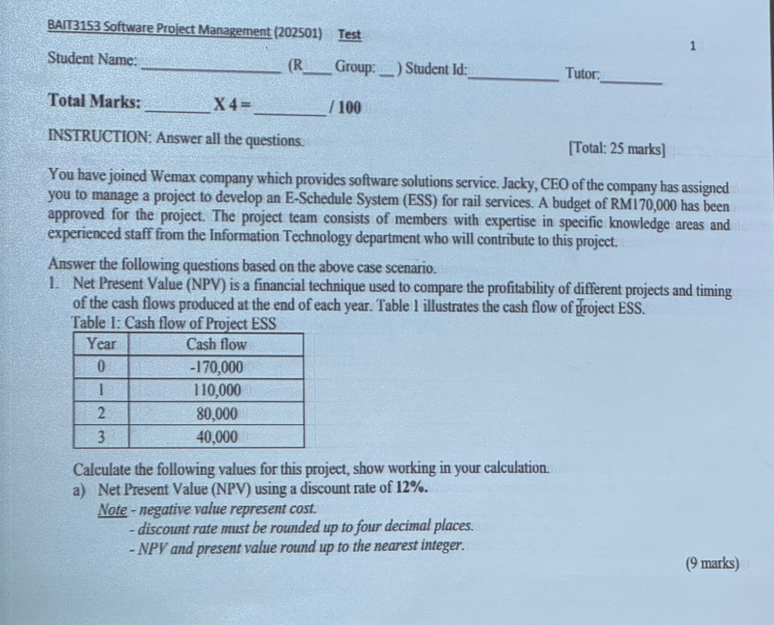
Answer:

Discount Rate: 12%
Project ESS | Year 0 | Year 1 | Year 2 | Year 3 | Total


Answer:

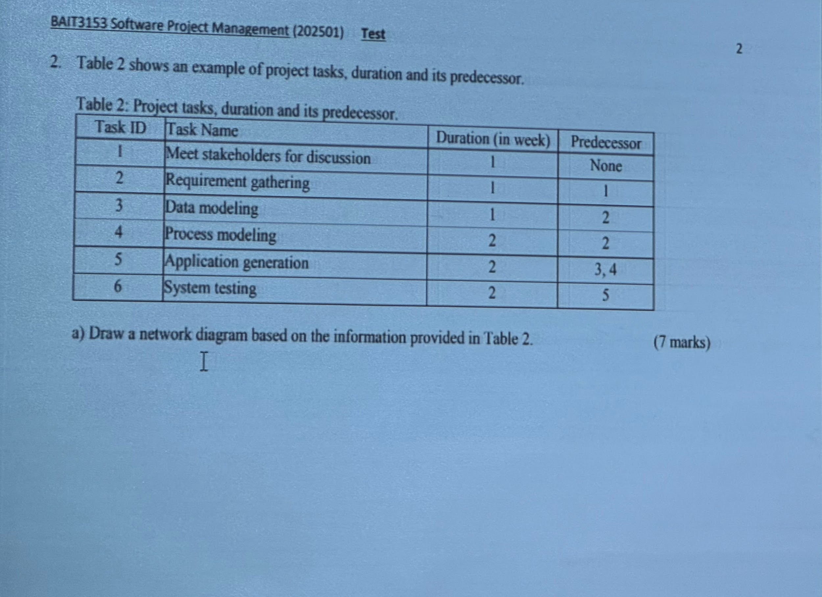
Answer:

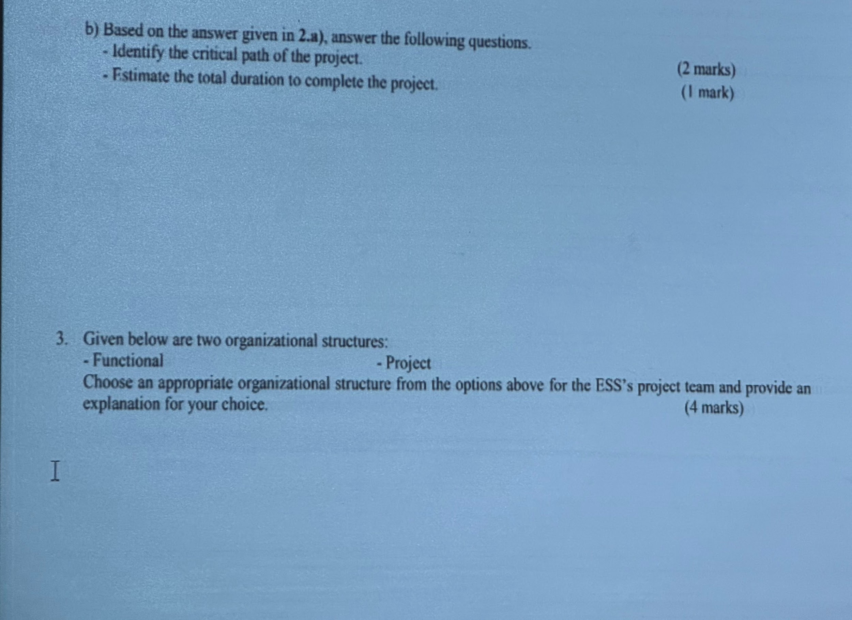
Answer:

